**Sampling Techniques**

1. **Simple random sample**
2. **Stratified Sample**
3. **Systematic sample**
4. **Cluster Sampling**
5. **Convenience Sampling**

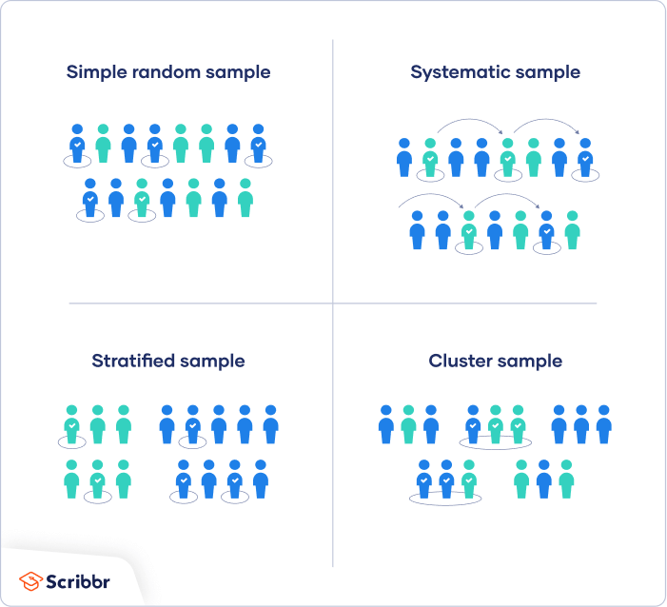

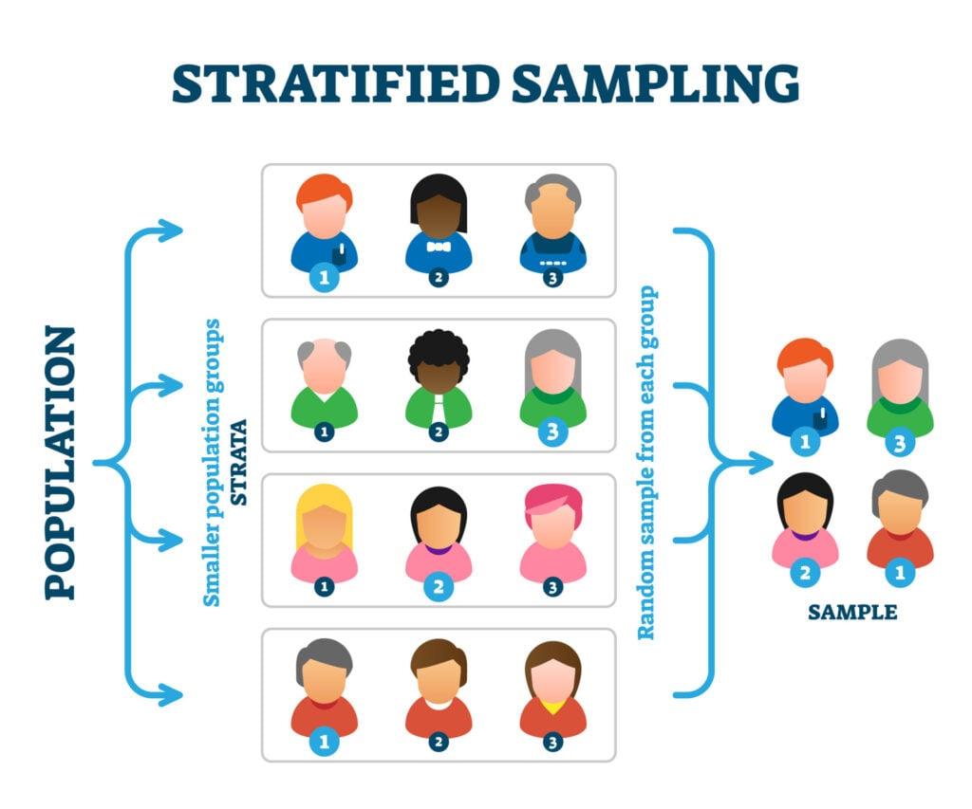

**Systematic sample**

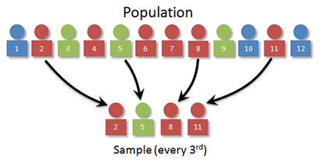

**Cluster Sampling**

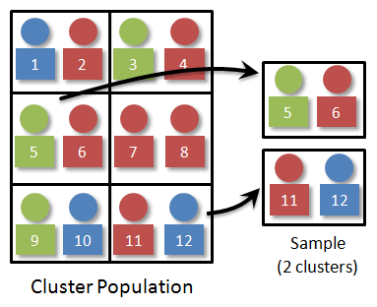

**Convenience Sampling**

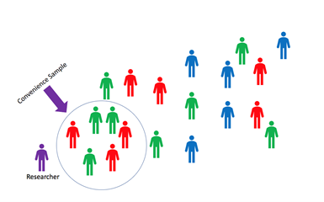

**Exercise:**

If I want to make a sample representing the class, how should I do it.

1. Simple Randon Sample  
     
   - We first number all the students in the class from 1 to 35  
   - Use a computer to generate 10 random numbers from 1 to 35 to form a sample
2. Systematic Sample

* We first number all the students in the class from 1 to 35
* Define a (arithmetic) sequence to select the sample. For example: 1, 4, 7, 10, 13, 16, 19, 22, 25, 28, 31, 34. Or 1, 5, 9, 13, 17, 21, 25, 29, 34.

1. Stratified Sample

* Divide the population into several groups
* Randomly select students from each groups to form the sample
* The number of selected students for each group should be proportional to the size of each group.   
    
  For example: dividing the class by gender, we have 8 female and 27 males. So we could randomly select 3 female from the group of 8 female and 9 males from the group of 27 males.

1. Cluster Sampling

* Divide the population into groups/clusters
* Select randomly a few clusters and use all the people in the cluster to form the sample.

1. Convenient Sampling

* Collect data from those who are convenient to the researcher.

For example: Collect data from the students who come to office hours.

**You try:**

Design five different ways to sample people in Rhode Island.